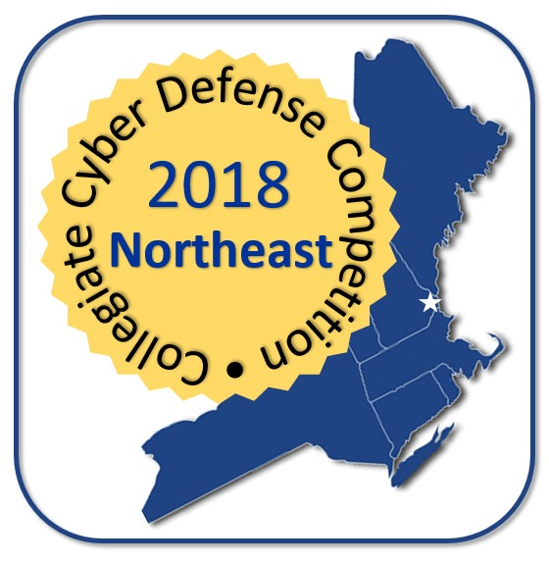

The 2018 Northeast Collegiate Cyber Defense Competition (NECCDC) will be held Durham, NH and hosted by the University of New Hampshire (UNH) during March 17-19, 2018. A qualifying round will be held to select the nine schools that will be invited to participate in the final round with UNH.

**Contact Information**

Web: <http://neccdc2018.org>

Twitter: <https://twitter.com/NECCDC2018>

Facebook <https://facebook.com/NECCDC2018>

Ken Graf is the event organizer: [ken.graf@cs.unh.edu](mailto:ken.graf@cs.unh.edu)

**Participating Institutions**

NECCDC draws from eligible schools in New England and New York. Currently the following schools are expected to participate; this list will expand as additional teams commit in the fall.

|  |  |  |
| --- | --- | --- |
| Alfred State College |  |  |
| https://encrypted-tbn0.gstatic.com/images?q=tbn:ANd9GcSiiO1J4KIldspQw5RTLLVnLwoLQa7Z0uqNOZ19wfkMfWUuP58fUXrfmxzQ |  | https://encrypted-tbn0.gstatic.com/images?q=tbn:ANd9GcTwE4oyPfAQJdcNmvEZtd17azYBVXwdRYJSgc8jYnyD9uw72mEd-eKGqX5Q |
|  | UNH Federation Services | http://absn.utica.edu/Templates/ion/utica_2016_2/Masters/logo1.png |
|  | http://www.singapore.idp.com/siteimages/pace-university-logo.jpg |  |
| https://encrypted-tbn0.gstatic.com/images?q=tbn:ANd9GcTnLwJL0S2LgCgfNtc5G9BdQtg3qFIpWfnxcYDac7rS8OnC0BqWtXLBaR05 |  | https://encrypted-tbn0.gstatic.com/images?q=tbn:ANd9GcTId_BtlR6oINQE10LLRF6IMS1jMVIZ_yvTJMiSTedFA0apxzIOPvzXjPMd |

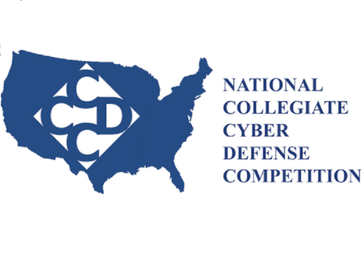**NECCDC Sponsorship Benefits**

|  |  |  |  |  |  |
| --- | --- | --- | --- | --- | --- |
|  |  | **Platinum**  **$20K** | **Gold**  **$10K** | **Silver**  **$5K** | **Bronze**  **$1K** |
|  |  |  |  |  |  |
| **Recognition** | Logo & link on NECCDC.NET | During event 1 year prior | During event 1 year prior | During event 3 months | During event 3 months |
| Banner at all events | Yes | Yes |  |  |
| Opening meeting recognition | Dedicated | Dedicated | Group | Group |
| **Recruiting** | Friday evening reception Table | Yes | Yes | Yes |  |
| Friday evening reception Tickets | 8 | 6 | 4 | 2 |
| Friday evening reception Video | Yes | Yes | Yes |  |
| Competitor's resumes | Qualifying and Finals | Finals |  |  |
| Welcome package insert | Yes | Yes | Yes | Yes |
| **Professional Networking** | CTF Invitation to speak | Yes | Yes |  |  |
| CTF Tickets | 8 | 6 | 4 | 2 |
| Awards Reception Initiation to speak | Yes |  |  |  |
| Awards Reception Tickets | 4 | 2 |  |  |
| White team appointments | 4 | 2 | 1 | 1 |
| Red team appointment | Yes |  |  |  |